Pharmacy Product System – National (PPS-N)

INSTALLATION GUIDE



Version 1.1.02

**August 2015**

**Department of Veterans Affairs**

**Office of Information and Technology (OIT)**

**Product Development**

**REVISION HISTORY**

|  |  |  |  |
| --- | --- | --- | --- |
| **Date** | **Version** | **Description** | **Author** |
| May 2015 | 1.1.02 | Updated date and version number to 1.1.02. Updated the PPS-N EAR file name. | Enterprise Application Maintenance |
| August 2014 | 1.1.01 | Updated version number to 1.1.01, updated the PPS-N EAR file name and the PPSNS MUMPS KIDS file name.  Added instructions to Undeploy the application. And made some formatting changes. | Enterprise Application Maintenance |
| November 2013 | 1.0.01 | Updated version number to 1.0.01, updated the PPS-N EAR file name and the PPSNS MUMPS KIDS file name. | Enterprise Application Maintenance |
| January 2013 | 1.0 | Updated document to modify formatting based on NRR Review. | SwRI |
| December 2012 | 1.0 | No applicable updates for this document | SwRI |
| November 2012 | 1.0 | Updated section 10.5.1 to include a reference to other applications updating the image folder | SwRI |
| October 2012 | 1.0 | Version 1.0 updates | SwRI |
| September 2012 | 1.0 | Version 1.0 | SwRI |

TABLE OF CONTENTS

1 INTRODUCTION 1

1.1 Document Background 1

1.2 Overview 1

2 Installation Instructions 3

2.1 Terminology 4

2.2 Assumptions 4

2.3 Database Tier Installation 5

2.3.1 Oracle Database (National) 5

2.3.1.1 Oracle Installation 5

2.3.1.2 Oracle Components 5

2.3.1.3 Oracle User Creation 7

2.3.1.4 Oracle Configuration 7

2.3.1.4.1 Oracle Database Parameters 7

2.3.1.4.2 Oracle Tablespaces 8

2.3.2 EPL Data Load 8

2.3.2.1 Dependency Installation 8

2.3.2.1.1 Java SE Development Kit (JDK) Installation 8

2.3.2.1.2 Apache Ant Installation 9

2.3.2.2 Ant Build Data Load 9

2.3.2.3 SQL Script Data Load (alternative to 2.3.2.2 Ant Build Data Load) 10

2.3.3 Post Database Creation / Migration Scripts 10

2.4 VistA/M System Installation User and Role Installation 12

2.5 WebLogic Installation Instructions 13

2.5.1 WebLogic Listen Address 13

2.5.2 Dependency Installation 14

2.5.3 Class Path 14

2.5.4 JTA Transaction Timeout 14

2.5.5 JDBC Data Source Configuration 17

2.5.6 Server Logs and Log4J configuration 23

2.5.6.1 Warning: Application Server’ Disk Space and Log Files 23

2.5.6.1.1 Domain Logging 24

2.5.6.1.2 Managed Server Logging 25

2.5.6.2 Installation of Log4J 27

2.5.7 Site Deployment Configuration 30

2.5.7.1 Site Number property 30

2.5.7.2 WebLogic Deployment Descriptor 31

2.5.7.3 KAAJEE Station Numbers 31

2.5.8 Install SQL Load Script Files 32

2.5.9 Deployment 32

2.5.10 Instructions to Undeploy 42

2.5.11 Installation of FDB_Images 43

2.5.11.1 Deployment of FDB_Images.zip 43

3 Checklist 45

3.1 External Connectivity 45

3.1.1 STS 45

3.2 Database Connectivity 45

3.3 Database Population 45

3.4 Database Permissions 45

3.5 Dependent WebLogic Deployments or Configurations 45

3.6 PPS-N Configuration 45

3.7 Site Number 45

4 Functionality Test 47

4.1 Assumptions 47

4.2 Deployment Verification 47

5 Backout Procedures 49

6 PPS-N Configuration File 51

7 Troubleshooting 53

7.1 In an SSL-enabled environment, the application’s responsiveness is extremely slow 53

LIST OF FIGURES

Figure 3‑1. WebLogic Console 3

Figure 3‑2. Security Roles 12

Figure 3‑3. Listen Address 13

Figure 3‑4. Domain Structure 15

Figure 3‑5. Settings for PRE 15

Figure 3‑6. JTA Timeout Seconds 16

Figure 3‑7. Domain Structure 17

Figure 3‑8. Summary of JDBC Data Sources 18

Figure 3‑9. JDBC Data Source Properties 18

Figure 3‑10. Transaction Options 19

Figure 3‑11. Connection Properties 20

Figure 3‑12. Test Database Connection 21

Figure 3‑13. Select Targets 22

Figure 3‑14. Summary of JDBC Data Sources 22

Figure 3‑15. Domain Log File Settings 24

Figure 3‑16. Managed Server Log File Settings 25

Figure 3‑17. Managed Server Advanced Log File Settings 26

Figure 3‑18. Deployments 32

Figure 3‑19. Install Deployment 33

Figure 3‑20. Install Application Assistant 33

Figure 3‑21. Locate Deployment to Install and Prepare for Deployment 34

Figure 3‑22. Upload a Deployment to the admin server 35

Figure 3‑23. Choose Targeting Style 36

Figure 3‑24. Select Deployment Targets 37

Figure 3‑25. Optional Settings 38

Figure 3‑26. Review Your Choices and Click Finish 39

Figure 3‑27. Settings for PRE-1.0-national 40

Figure 3‑28. Domain Structure 41

Figure 3‑29. Summary of Deployments 41

Figure 3‑30. Summary of Deployments - PPS-N Deployment Active 42

LIST OF TABLES

Table 3‑1. Terminology 4

Table 3‑2. Oracle Users 7

Table 3‑3. PPS-N Tablespaces 8

Table 3‑4. Deployment Location Database Configuration 17

# INTRODUCTION

The information contained in this Pharmacy Product System (PPS) – National (PPS-N) Installation Guide applies to PPS-N Version 1.1.02.

The purpose of this Installation Guide (IG) is to define the pre-requisites for the PPS-N application to function, the artifacts that must be deployed and the configuration of those artifacts. The deployable artifacts associated with this project will be the PPS-N Enterprise Product List (EPL), the PPS-N deployable Enterprise Archive (EAR) file and the [Massachusetts General Hospital](http://en.wikipedia.org/wiki/Massachusetts_General_Hospital) Utility Multi-Programming System (MUMPS) patches that will be deployed on the National Drug File Management System (NDF MS). Additionally, the documentation associated with this project will discuss the interfaces to the NDF MS system, the interfaces to the First DataBank (FDB) MedKnowledge Framework, the interface to the Veterans Enterprise Terminology Service (VETS) system and the methodology for connecting to the Federal Supply Service (FSS) database. The coding for the NDF MS system and FDB MedKnowledge Framework interfaces will be done by the contractor. The VETS system will be maintained by VETS personnel and the FSS database will be maintained by FSS personnel.

## Document Background

This document details the steps required to install and configure the PPS-N v1.1.02 software, the terminology used for the configuration and deployment of the software, and the assumptions for installing the software. Additionally, this document details how to install and configure the database environment.

## Overview

The following list provides a brief description of the sections included in this document:

Section 1: Provides introductory material delineating the purpose of the PRE Initiative and the PPS projects

Section 2: Presents an overview of the document

Section 3:Presents the installation instructions for PPS-N

Section 4: Presents functionality tests to confirm that the installation was successful

Text in a Courier New font indicates text, commands, or settings that must be typed, executed, or configured to complete the installation.

*(This page included for two-sided copying.)*

# Installation Instructions

The following sections detail the steps required to install the PPS-N software. Section 3.1 details the terminology used for the configuration and deployment of the software. Section 3.2 outlines the assumptions for installing the software. While the system may be configured to run outside the given assumptions, doing so requires modifications that are not detailed in this document. Section 3.3 describes how to install and configure the Oracle databases. Section 3.4 describes installation and configuration of the VistA patches. Finally, Section 3.5 describes how to install and configure the PPS-N software in WebLogic.

In order to understand the installation and verification process, the reader should be familiar with the WebLogic console shown in Figure 3‑1. The WebLogic console is a Web page viewable from any Internet browser; however, Internet Explorer, Version 9, is recommended. The WebLogic console is generally divided into two columns. The left column contains the Change Center, the Domain Structure, and other informational panels. The right column displays panels containing additional options or configuration details.

Note: With the exception of the Change Center and Domain Structure, all WebLogic console panels shown in the figures contained in this document are found in the right column of the WebLogic console. Whenever examples are given with the text, “For example,” the given value may be different depending on the specific server configuration. When the text, “For example,” is not provided, the text supplied must be entered exactly as specified for the PPS-N application to operate properly.

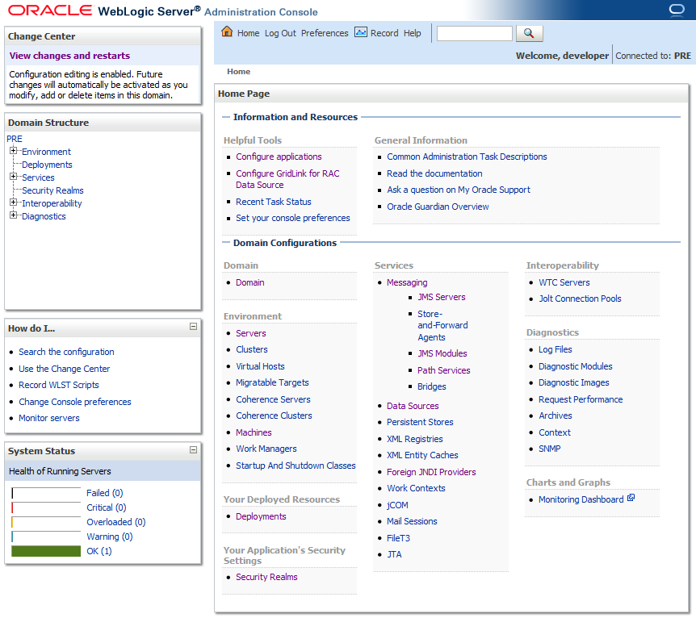

Figure 3‑1. WebLogic Console

## Terminology

In an effort to make these installation instructions as general as possible for installation at any site, a few terms are used throughout the installation instructions with the intent that they be replaced with site-specific values. Table 3‑1 contains a list of those terms used only within this document as well as **sample** site-specific values for each term.

Table 3‑1. Terminology

| Term | Definition | Sample |
| --- | --- | --- |
| Database Server | Machine on which Oracle is installed and runs | PPS-N-DB |
| Deployment Server | WebLogic managed server where PPS-N is deployed | NationalPharmacyServer |
| Deployment Server Port | Port on which the Deployment Server is listening | 8021 |
| Deployment Server class path directory | Folder location on the Deployment Server where libraries on the class path are located (see WebLogic documentation for instructions on setting a WebLogic managed server class path) | /opt/oracle/middleware/domains/PRE/lib |
| Java Database Connectivity (JDBC) Universal Resource Locator (URL) | URL to connect to Oracle database | jdbc:Oracle://pps-n-DB:1521/FDB_DIF |

## Assumptions

Hardware specifications for PPS-N are found in the PPS-N v1.0 Version Description Document which is delivered as a companion document to this Installation Guide.

The installation instructions found within this guide are intended to be performed on a clean installation of WebLogic 10.3.2 (10.3.5 is the latest as of July 2011), with a separate managed server to act as the Deployment Server. For details on completing the installation of the following items, please refer to each item’s installation and configuration documentation for WebLogic supplied by Oracle.

For successful deployment of the PPS-N software at a site, the following assumptions must be met:

* The Deployment Server is configured and running via the WebLogic Node Manager.
* WebLogic is configured to run with the Java Standard Edition Development Kit, Version 1.6.0_16 (or better).
* Access to the WebLogic console is by means of any valid administrative user name and password.
* Oracle 11g database driver libraries are present on the class path for the respective Deployment Servers.
* Red Hat Enterprise Linux is properly installed.
* Installation instructions are followed in the order presented within this Installation Guide.

## Database Tier Installation

This section describes the operating system and software for the PPS-N Database Tier installation and configuration. Initially, install and configure the operating system and software according to the manufacturer’s specifications. Then configure as specified in Section 3.3.1 through Section 3.3.2 for PPS-to function properly. An Oracle database is implemented at the national level. **The installation instructions in Section 3.3.1 should be carried out by a qualified individual, such as a certified Database Administrator (DBA).**

### Oracle Database (National)

The National PPS-N EPL is designed to be operating system independent but these installation instructions have been tested only on the Red Hat Linux operating system. Oracle 11g Enterprise Edition Release 11.2.0.*n* – Production must be properly installed and configured. The following sections describe the installation, features, user creation, and configuration for the Oracle database.

#### Oracle Installation

A proper installation of the Oracle Relational Database Management System (RDBMS) is one in which the Oracle Universal Installer was used to perform an error-free installation and a general purpose instance was created. A properly configured Oracle RDBMS is one in which the associated Oracle application development and configuration tools, namely SQL*Plus and Oracle Enterprise Manager, can be used to connect to the instance through Transparent Network Substrate alias.

#### Oracle Components

During the installation of Oracle, described in the *Oracle 11g Quick Installation Guide*, several components are selected for optional installation, as listed below. Given the platform independent nature of these installation instructions for the database, platform dependent components are not listed here. Instead, generic features and functions of the Oracle 11g database are identified.

The following features are required by the PPS-N system:

* Procedural Language/Structured Query Language (PL/SQL) Native Compilation
* PL/SQL API to LDAP – DBMS_LDAP

The following additional features have been tested with the PPS-N system:

* Fail Safe
* Integrated Clusterware
* Automatic Workload Management
* Password Management
* Comprehensive eXtensible Markup Language (XML) Support in the Database
* Enterprise Manager
* Automatic Memory Management
* Automatic Storage Management
* Automatic Undo Management
* Server Managed Backup and Recovery

The following features are not required and were not tested with the PPS-N system:

Flashback Query

Table, Database, and Transaction Query

Data Guard

Java Native Compilation

Encryption Toolkit

Virtual Private Database

Fine Grained Auditing

Java Support

JDBC Drivers on server

PL/SQL Server Pages

Java Server Pages

COM (Component Object Model) Automation

Microsoft Transaction Server/COM+ Integration

Open Database Connectivity (ODBC) DB on server

Object Linking and Embedding, Database (OLE DB) on server

Data Compression

Transportable Tablespaces

Star Query Optimization

Summary Management

Materialized View Query Rewrite

Oracle Streams

Advanced Queuing

Workflow

Distributed Queries

Distributed Transactions

Database Workspace Management

Ultra Search

interMedia

Text

Oracle Analytic Functions

Demonstration Files

The following functions are not required and were not tested with the PPS-N system:

Replication

Materialized Views

Remote Authentication

Quotas

Profiles

Resource Plans

Stored Outlines

#### Oracle User Creation

Two users must be created within the Oracle database to support PPS-N. Table 3‑2 presents example username and password for each Oracle user. Note that user names and passwords used must match exactly those used to configure the JDBC data sources in Section 3.5.4; these are only **sample** values.

Table 3‑2. Oracle Users

| Username | Password |
| --- | --- |
| PPSNEPL | pharmacy |
| FDB_DIF | FDB_DIF123 |

The PPSNEPL user will be the owner of the PPS-N schema. The FDB_DIF user will be the owner of the FDB_DIF schema.

Both users must have the following roles and privileges:

* CONNECT
* RESOURCE
* CREATE SESSION
* CREATE VIEW
* SELECT_CATALOG_ROLE
* UNLIMITED TABLESPACE

#### Oracle Configuration

The PPS-N Oracle Database is the primary data repository for the PPS-N application on the National PPS-N instance. The database should be installed and configured appropriately for the PPS-N operating environment.

Two schemas must be created. If not already installed, the FDB_DIF schema can be created by running a script, provided with the First DataBank software. Upon creation, the tables may be populated using First DataBank Data Updater Installation. Update instructions are available in the *FDB Data Updater Software Users Guide.*

The EPL schema must also be created in the database instance. The EPL table creation and population scripts are run from a separate process. For instructions on loading the EPL data, refer to Section 3.3.2.

##### Oracle Database Parameters

The following Oracle database parameters are required for the PPS-N application:

* NLS Language = American
* NLS Territory = America

Character Set = AL32UTF8

##### Oracle Tablespaces

The PPS-N application data is contained in two tablespaces. The size of each tablespace is shown in Table 3‑3.

Table 3‑3. PPS-N Tablespaces

|  |  |
| --- | --- |
| Tablespace Name | Size (MB) |
| TEMP | 188 |
| USERS | 3,000 |

### EPL Data Load

The following instructions should be followed to install the base EPL Data Load. Prior to following any of the installation instructions, the dependencies in Section 2.3.2.1 must be installed. After the dependencies have been installed, follow the instructions in Section 2.3.2.2 to load the data using the Ant build.

#### Dependency Installation

Two other software packages must be installed prior to loading the EPL data.

Prior to installing the dependencies, follow these steps:

1. Copy the PPSN-1_SourceCode.zip file to the chosen target folder. The file is located on the disk distributed with the Version Description Document. No particular location is required.
2. Unzip the file.

This will create the following folder structure:

PS_PPS_Bld\PS_PPS_bld

PS_PPS_Bld\PS_PPS_lib

PS_PPS_Dev\PS_PPS_common

PS_PPS_Dev\PS_PPS_interface

PS_PPS_Dev\PS_PPS_domain

PS_PPS_Dev\PS_PPS_srv

PS_PPS_Dev\PS_PPS_ui

The PS_PPS_Dev\PS_PPS_domain folder contains the files necessary to create and load the EPL tables.

##### Java SE Development Kit (JDK) Installation

Java SE Development Kit (JDK) Version 1.6.0_16 or greater, must be installed prior to loading the PPS-N EPL data load. PPS-N was tested with the current JDK release (as of July 2011), 1.6.0_26. Please follow the installation instructions provided by Sun to complete the installation. For the Microsoft Windows operating system, refer to <http://java.sun.com/javase/6/webnotes/install/jdk/install-windows.html>; for the Linux operating system, refer to <http://java.sun.com/javase/6/webnotes/install/jdk/install-linux.html>. Once complete, this new installation of Java must be set as the default Java distribution (i.e., the installation folder must be set as JAVA_HOME).

##### Apache Ant Installation

Apache Ant, **version 1.7.1**, must be installed prior to loading the PPS-N EPL data load. Please follow the installation instructions provided by Apache at <http://ant.apache.org/manual/install.html>. Once complete, a user must be able to execute Ant by typing ant at the command line from any folder on the system (i.e., Ant’s bin folder must be on the system’s path).

#### Ant Build Data Load

Please complete these steps to load the PPS-N data. **Alternatively**, you can skip this section and use the instructions in section 3.3.2.3 to load data.

1. Navigate to the folder where the PPSN-1_SourceCode.zip file was extracted.
2. Navigate to the PS_PPS_Dev/PS_PPS_common/etc/build/template/properties folder.
3. Open the project.properties file for editing.
4. Change the deploy.environment attribute’s value to dataload. For example: deploy.environment=dataload
5. Save the changes and close the project.properties file.
6. Navigate to the PS_PPS_Dev/PS_PPS_common/etc/build/template/properties/deploy folder.
7. Open the dataload.properties file for editing.
8. Change the local.hosts attribute value to an empty value. For example:  
   local.hosts=  
   This prevents the dataload from attempting to load the Local data, which is not applicable at this time.
9. Change the nationalserver.database.url.host attribute value to the hostname of the database server. The default value is localhost. For example:  
   nationalserver.database.url.host=localhost  
   This value pertains to the attribute key names for the user, password and schema in the next step.
10. Change all attribute key names of localhost under the nationalserver properties section to the name of the database server used in step 9. For example: localhost.EPLN.user=ppsnepl should change to <database>.EPLN.user=ppsnepl, localhost.EPLN.password becomes <database>.EPLN.password and localhost.EPLN.schema becomes <database>.EPLN.schema.
11. With respect to the previous step (which may have changed the key names to something other than localhost), change localhost.EPLN.user, localhost.EPLN.password and localhost.EPLN.schema attribute values to the correct values for the National PPS-N database. For example: localhost.EPLN.user=ppsnepl and localhost.EPLN.password=pharmacy.
12. If the database name used on the install was not EPLN, change the nationalserver.national.database.names attribute value to the name of the National EPL database. For example:

nationalserver.national.database.names=EPLN

Ensure all instances of “EPLN” occurring within key names of step 10 are also changed. For example, if step 10 changed localhost to dbserver and this step changed EPLN to EPLNAT, the following would be the final result:

dbserver.EPLNAT.user=ppsnepl  
dbserver.EPLNAT.password=pharmacy  
dbserver.EPLNAT.schema=ppsnepl

1. Save the changes and close the dataload.properties file.
2. Navigate to the PS_PPS_Dev/PS_PPS_domain/etc/build/template/properties folder.
3. Open the oracle.properties file for editing.
4. If the port on which Oracle is listening is not port 1521, change the database.url.port attribute value to the correct port. For example: database.url.port=1522
5. Save the changes and close the oracle.properties file.
6. Navigate to the PS_PPS_Dev/PS_PPS_domain folder.
7. Run the ant build target desired.
   * + refreshDatabase – Refresh the database with data used for non-migration test procedures.   
       command: ant refreshDatabase

After the build completes, the current PPS-N EPL database instance has both its tables created and data loaded.

#### SQL Script Data Load (alternative to 2.3.2.2 Ant Build Data Load)

As an alternative, you may load the database with the following SQL scripts found in PPSNEPLRefreshDb-1.zip archive. Please use an appropriate database client (e.g. TOAD, SQL*Plus, etc.) to execute these scripts. The order of execution is required:

1. NationalEPL.ddl
2. NationalEPL-FK.ddl
3. PPSNEPLRefreshDB15.sql

### Post Database Creation / Migration Scripts

The following scripts will need to be run after table creation and data population. These scripts require logging in to the database using an account that has **SYS_DBA** privileges.   
***This script also needs to be run after each Migration done from within the application.***

1. Login to the SQL client using a database account that has **SYS_DBA** privileges
2. Execute the script below (also available in the SQL script archive: PPSNEPLRefreshDb-1.zip)

|  |
| --- |
| --Script to create the PPSNEPL_READ_ONLY role.  --Provides read only access to PPSNEPL schema objects.  DROP ROLE PPSNEPL_READ_ONLY_ROLE;  CREATE ROLE PPSNEPL_READ_ONLY_ROLE NOT IDENTIFIED;  --suppress display of messages for building command file  SET TERM OFF  SET ECHO OFF  SET HEADING OFF  SET FEEDBACK OFF  SET PAGESIZE 0  SET LINESIZE 1000  SET VERIFY OFF  spool grant_PPSN_read_only_role.sql  SELECT 'GRANT SELECT ON PPSNEPL.' || TABLE_NAME|| ' TO PPSNEPL_READ_ONLY_ROLE; ' FROM ALL_TABLES WHERE OWNER ='PPSNEPL';  spool off  --reset display of messages for verification  SET TERM ON  SET ECHO ON  SET HEADING ON  SET FEEDBACK ON  SET PAGESIZE 300  SET VERIFY ON  spool grant_PPSN_read_only_role.log  start grant_PPSN_read_only_role.sql  GRANT PPSNEPL_READ_ONLY_ROLE TO SYSTEM WITH ADMIN OPTION;  spool off |

1. This process creates and executes the file grant_PPSN_read_only_role.sql. This will ensure that all necessary privileges are granted to the read-only role.
2. Open the grant_PPSN_read_only_role.***log*** file and search the log file for any errors.
3. Execute the script below which will create the user and assign the required roles. The script is also available in the SQL script archive, PPSNEPLRefreshDb-1.zip.

|  |
| --- |
| DROP USER PPSNEPL_READ_ONLY CASCADE;  CREATE USER PPSNEPL_READ_ONLY  IDENTIFIED BY PPSNEPL_READ_ONLY123  DEFAULT TABLESPACE USERS  TEMPORARY TABLESPACE TEMP  PROFILE DEFAULT  ACCOUNT UNLOCK;  -- 3 Roles for PPSNEPL_READ_ONLY  GRANT CONNECT TO PPSNEPL_READ_ONLY;  GRANT PPSNEPL_READ_ONLY_ROLE TO PPSNEPL_READ_ONLY;  GRANT FDB_DIF_READ_ONLY_ROLE TO PPSNEPL_READ_ONLY;  ALTER USER PPSNEPL_READ_ONLY DEFAULT ROLE ALL;  -- 1 Tablespace Quota for PPSNEPL_READ_ONLY  ALTER USER PPSNEPL_READ_ONLY QUOTA UNLIMITED ON USERS; |

1. View screen output for any errors

## VistA/M System Installation User and Role Installation

This section details the steps required to install patches, add users, assign roles, and install remote procedure calls (RPCs) to the PPS-N VistA instance. For this code release, a user, for example one with an access code of PNM1N1, with the ‘PSS_PPSN_MANAGER’ key and a user, for example one with an access code of PMM1N1, with the ‘PSS_PPSN_MIGRATOR’ key are required. The following figure details the security role keys used within and recognized by this application. Please note prior “PEPS” security role keys have been removed and are no longer recognized.

|  |
| --- |
| Security Role Keys |
| PSS_PPSN_SUPERVISOR |
| PSS_PPSN_MANAGER |
| PSS_PPSN_VIEWER |
| PSS_PPSN_SECOND_APPROVER |
| PSS_PPSN_MIGRATOR |

Figure 3‑2. Security Roles

PPS-N has two M patches, PPSN_11_15.KID (Migration) and PPSNS_11_17.KID (Synchronization), which include versions of the migration and synchronization RPC code.  These KIDS patches need to be loaded and installed on the NDF server using the standard Kernel Installation & Distribution Systems Option in the System Manager menu. After the PPSN_11_15.KID patch is loaded, the PPSN*1.1*15 package can be installed. After the PPSNS_11_17.KID patch is loaded, the PPSNS*1.1*17 package can be installed.

VistALink 1.6 must be installed on the NDF. See the VistALink documentation for installing VistALink. Once installed, VistALink can be started using the D EN^XOBUM command. Once VistALink is running, the listener must be started using the SL (Start Listener) option. If VistALink is already running, the listener can be started using the Foundations Management menu found in the Operations Management menu. If a connection proxy has not been specified for VistALink, the NPF CONNECTOR PROXY can be specified using the CP (Enter/Edit Connector Proxy User) option on the Foundations Management menu. Creating the Connector Proxy User via the Foundations Management menu should ensure that the Connector Proxy User has the correct properties.

This release contains 3 Remote Procedure Calls “PPS NDFMS MIGR RPC”, “PPS NDFMS MIGR SYNC” and “PPS NDFMS SYNC”.  If not already in the XOBV VISTALINK TESTER option, these RPCs must be added to the XOBV VISTALINK TESTER option. The RPCs can be added to the XOBV VISTALINK TESTER option by using the FILEMAN ENTER OR EDIT FILE ENTRIES command to modify the XOBV VISTALINK TESTER entry in the OPTION file by adding the options at the “Select RPC” prompt (RPCKEY and RULES can be defaulted to null).

The PPS proxy user, for example PPUSER, APPLICATION PROXY, must have the XOBV VISTALINK TESTER option as a secondary menu option. The XOBV VISTALINK TESTER option can be added as a secondary menu option by using the FILEMAN ENTER OR EDIT FILE ENTRIES command to modify the NEW PERSON entry for the PPS proxy user by adding XOBV VISTALINK TESTER at the “Select SECONDARY MENU OPTIONS” prompt.

A line must be included in the /opt/oracle/middleware/domains/PRE/CommonServices/VL-1.6/ gov.va.med.vistalink.connectorConfig.xml file on the WebLogic server with the IP address and port of the VistALink listener (selectable when the Listener is turned on); the primary station ID of the NDF; the access and verify codes for the user being used for the connection, for example the XOBV VISTALINK TESTER; and other information necessary for the connection to be made to the VistALink listener in the NDF.

The DUZ and division of the PPS-N PROXY USER (the system user account capable of accessing the RPC), the division where that user exists, the connection specification to be used (for example DUZ) and the RPC timeout (for example 60 seconds) must be entered into the PPS-NConfig.xml in the …/domains/PRE/config directory on the WebLogic server. The configuration file is shown in Section 7

## WebLogic Installation Instructions

This section details the steps required to configure and deploy PPS-N onto WebLogic.

### WebLogic Listen Address

PPS-N is installed on a managed server (e.g. NationalPharmacyServer), and WebLogic 10.3 requires that the Listener Address field be set on the servers. Set this value on the server’s General Settings tab. For reference, see Figure 3‑3.

Note: The port that the application is installed on must also be set in the Configuration file shown in Section 7 because the JNDI lookup is site specific. If the port is not also defined in the configuration file the application will not work correctly.

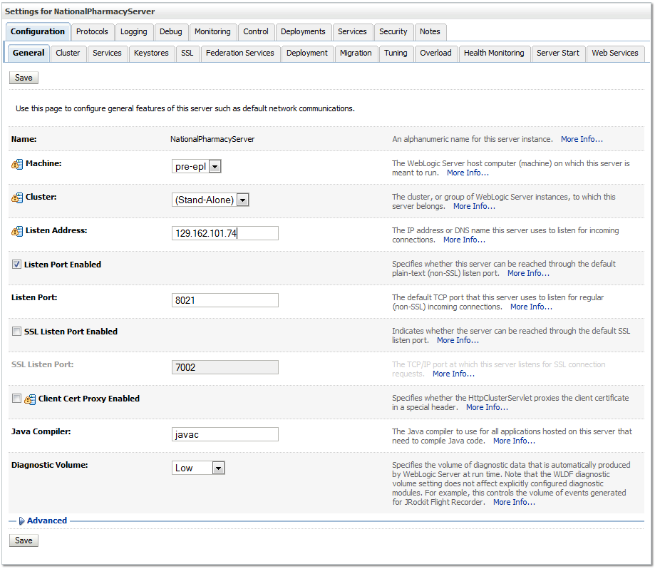

Figure 3‑3. Listen Address

### Dependency Installation

VistALink, Version 1.6.0.028 and KAAJEE Security Provider, Version 1.1.0.002 software packages must be installed prior to deployment of PPS-N on to WebLogic. Follow the respective installation guides supplied by the VA for this software prior to continuing with the PPS-N installation.

### Class Path

In order for the JDBC data sources to be added to the WebLogic configuration, the JDBC driver must first be added to the Deployment Server’s class path. Use the JDBC driver provided within the Oracle distributions and the WebLogic documentation provided by Oracle (formerly BEA) to add the driver to the class path.

**Important:** Third-party database drivers, e.g. JDBC drivers for MS SQL Server from Microsoft, will need to be deployed onto the WebLogic server’s classpath, ${WL_HOME}/server/lib. Additionally, any such third-party drivers will also need to be prepended to the WEBLOGIC_CLASSPATH variable definition in the ${WL_HOME}/common/bin/commEnv.sh file. E.g. “WEBLOGIC_CLASSPATH=”${WL_HOME}/server/lib/sqljdbc4.jar${CLASSPATHSEP} ……(rest of definition).” Any modification here requires the entire WebLogic server system to be restarted. E.g. AdminServer and any Managed Servers.

* The MS SQLServer JDBC driver can be extracted from the application,
  + PPS-1.1.02-national.ear\lib\database\sqljdbc4.jar
  + Or from the source zip file: Common\lib\database\sqljdbc4.jar

The PPS-N EAR file contains all the remaining required libraries for the proper functioning of the application. If any other applications have been deployed to the Deployment Server, there may be conflicting third-party libraries in the Deployment Server’s class path directories that will cause the PPS-N application to operate differently than expected. If versions on the Deployment Server’s class path differ from those defined in the PPS-N 1.0 Version Description Document, then the preferred solution would be to remove the library from the Deployment Server’s class path. If that is not possible, replace the libraries with the PPS-N versions.

Two JAXB version 2.1.10 libraries must be at the very beginning of the class path due to PPS-N incompatibility with the JAXB version bundled with WebLogic, JAXB version 2.1.9. The jaxb-api.jar and jaxb-impl.jar files are available within the PPS-N EAR. These JAR files must come before any WebLogic JAR files, as the classes found within the JAR files supersede the original WebLogic supplied classes. The JAR files include JAXB bug fixes required for PPS-N to function properly, particularly <https://jaxb.dev.java.net/issues/show_bug.cgi?id=565>.

### JTA Transaction Timeout

The default WebLogic Java Transaction API (JTA) timeout is 30 seconds. This time is sufficient for all transactions in PPS-N, with the exception of the FDB DIF update process, which can take several minutes. Follow the instructions below to set the JTA timeout to 600 seconds, or 10 minutes. If the migration database refresh scripts transaction times out even after ten minutes, additional time can be allotted to the timeout setting by following the same process.

Perform the following instructions for each WebLogic domain where PPS-N will be deployed.

1. Open and log into the WebLogic console, using an administrative user name and password. The WebLogic console is located at: http://<Deployment Machine>:7001/console.
2. Within the Domain Structure panel found in the left column of the WebLogic console, click on the WebLogic domain’s node. In Figure 3‑5, the WebLogic domain is named PRE.

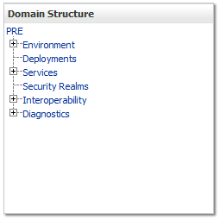

**Figure 3‑4. Domain Structure**

1. WebLogic will now display the panel Settings for PRE in the right column of the console, where details of the WebLogic domain are set. For reference, see Figure 3‑5.

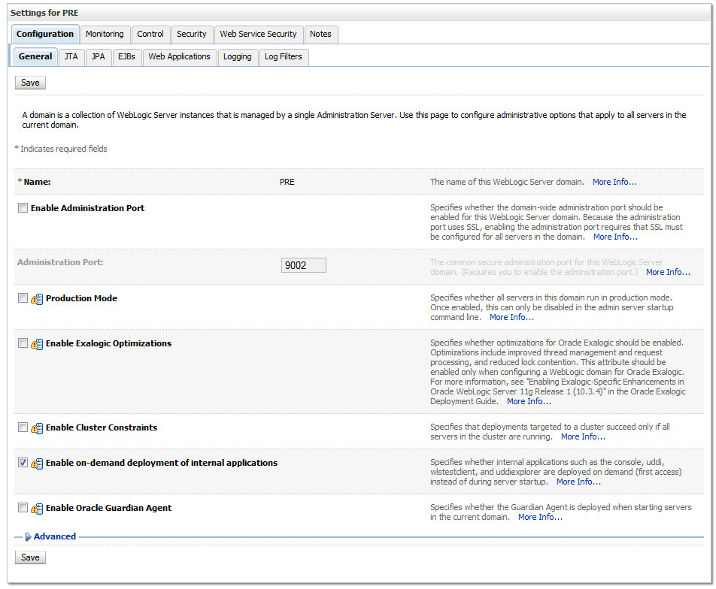

Figure 3‑5. Settings for PRE

1. Select the JTA tab.
2. WebLogic will now display the panel Settings for PRE in the right column of the console. Within the panel is JTA within the Configuration tab, where the JTA timeout will be configured. For reference, see Figure 3‑6.

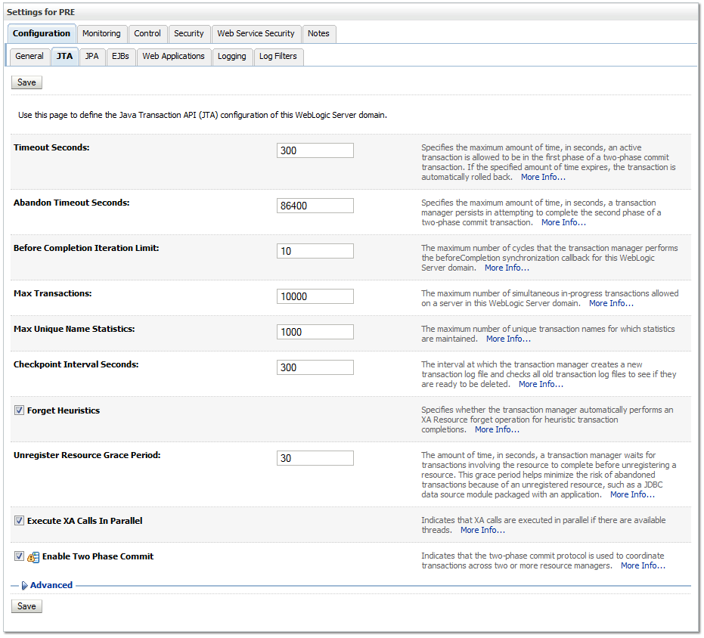

Figure 3‑6. JTA Timeout Seconds

1. For the Timeout Seconds, type **600**. Please note this has changed since interim release 1.0.5.
2. Click Save.

### JDBC Data Source Configuration

PPS-N uses database connections by means of JDBC data sources to FDB DIF and to the Local EPL or the National EPL. Repeat the following instructions at each deployment location to create a new data source for each database. The databases required at each deployment location as well as their respective database driver and JNDI name settings are provided in Table 3‑4.

Table 3‑4. Deployment Location Database Configuration

|  |  |  |  |  |  |
| --- | --- | --- | --- | --- | --- |
| Deployment Location | Database | Database Type | Database Driver | Transaction Options | JNDI Name |
| National | FDB DIF | Oracle | Oracle’s Driver (Thin XA) Versions: 9.0.1 and later | Supports Global Transactions | datasource/FDB-DIF |
| National EPL | Oracle | Oracle’s Driver (Thin XA) Versions: 9.0.1 and later | Supports Global Transactions | datasource/NationalEPL |
| FSS | MS SQL Server | Microsoft’s MS SQL Server Driver (Type 4) Versions: 2005 | Supports Global Transactions  Emulate Two-phase Commit | datasource/PRE-FSS |

1. Open and log on to the WebLogic console, using an administrative user name and password. The WebLogic console is located at: http://<Deployment Machine>:7001/console.
2. Within the Domain Structure panel found in the left column of the WebLogic console, click on the Services > Data Sources node. For reference, see Figure 3‑7. Please note that these images were captured from WebLogic 10.3.5, as such the Domain Structure navigation may vary slightly. For example, WebLogic 10.3.2 may require the following navigation sequence instead: Services > JDBC > Data Sources.

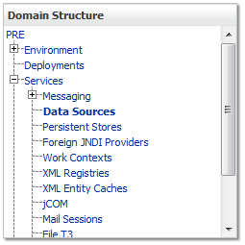

Figure 3‑7. Domain Structure

1. Click New in the Summary of JDBC Data Sources panel found in the right column of the WebLogic console and choose Generic Datasource from the drop down list. For reference, see Figure 3‑8.

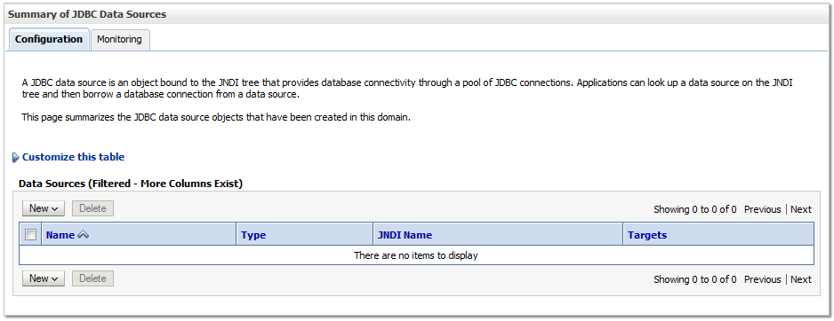

Figure 3‑8. Summary of JDBC Data Sources

1. WebLogic will now display the panel Create a New JDBC Data Source in the right column of the console, where details of the new data source are set. For reference, see Figure 3‑9.

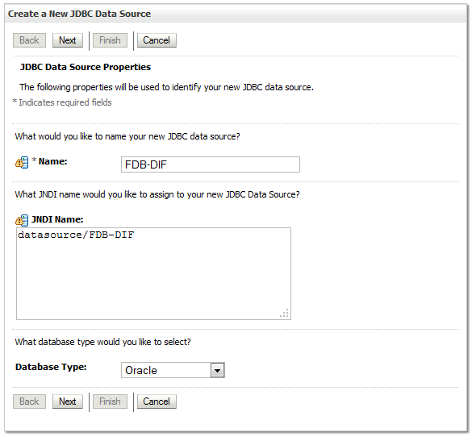

Figure 3‑9. JDBC Data Source Properties

1. For the Name, type a unique name. For example, FDB-DIF.
2. For the JNDI Name, type the appropriate JNDI found in Figure 3‑9. For example, datasource/FDB-DIF.
3. For the Database Type, select the appropriate type found in Table 3‑4. For example, Oracle.
4. Click Next.
5. For the Database Driver, verify that the correct driver is selected as found in Table 3‑4. For example, Oracle’s Driver (Thin XA) Version: 9.0.1 and later.
6. Click Next.
7. WebLogic will now display the panel Transaction Options in the right column of the console, where the transaction information for this data source is displayed. For reference, see Figure 3‑10.

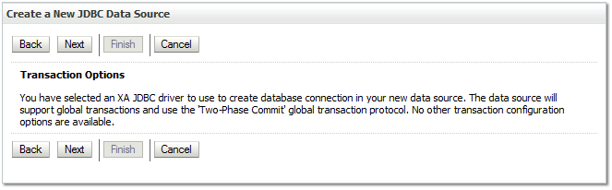

Figure 3‑10. Transaction Options

1. Click Next.
2. WebLogic will now display the panel Connection Properties in the right column of the console, where the connection pool attributes are set. For reference, see Figure 3‑11.

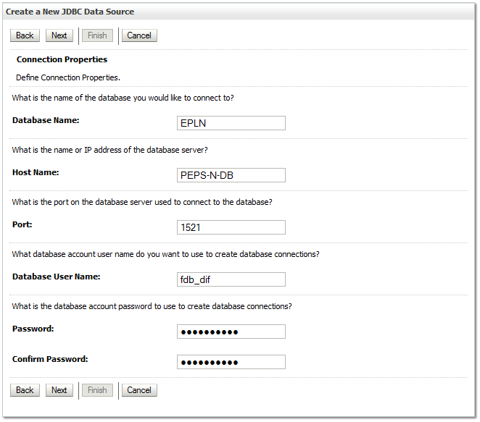

Figure 3‑11. Connection Properties

1. For Database Name, type the name of the database to which PPS-N will connect. For example, EPLN.
2. For Host Name, type the name of the machine on which the database is running. For example, PPS-N-DB.
3. For Port, type the port on which the database is listening. For example, 1521.
4. For Database User Name, type the user to connect to the FDB database. For example, fdb_dif. The user entered should be the same as the user configured in Section 2.3.1.3. For Password and Confirm Password, type the password for the user given previously. For example, fdb_dif123.
5. Click Next.
6. WebLogic will now display the panel Test Database Connection in the right column of the console, where the new data source can be tested. For reference, see Figure 3‑12.

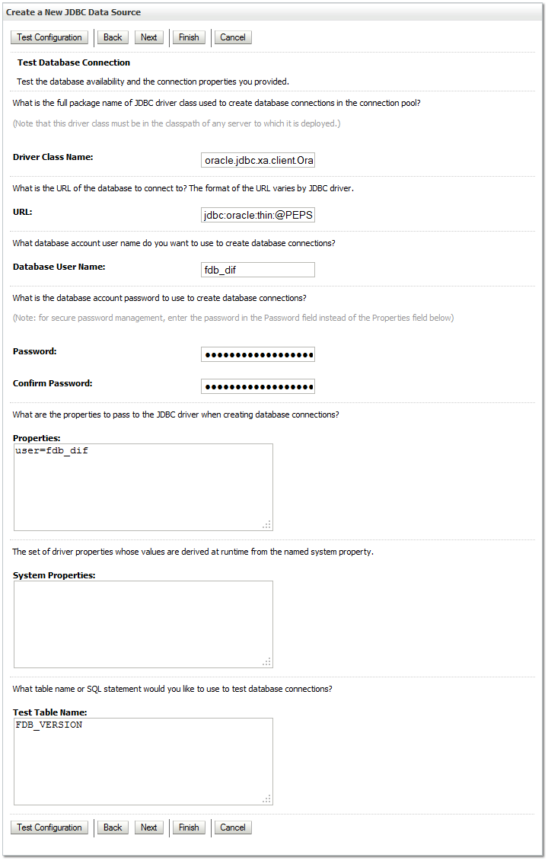

**Figure 3‑12. Test Database Connection**

1. Leave all values as set by default, with the exception of Test Table Name. For FDB DIF databases, type fdb_version. For EPL databases, type epl_products.
2. For the FSS datasource, you will be connecting to an MS SQL Server database, so items listed in **Figure 3‑12. Test Database Connection** will be slightly different and require changing to the following:  
   URL: jdbc:sqlserver://*hostname*:1433  
   Driver Class Name: com.microsoft.sqlserver.jdbc.SQLServerDriver  
   Test Table Name: DI_DRUGITEMNDC
3. Click Next.
4. WebLogic will now display the panel Select Targets in the right column of the console, where the target server is selected for the new data source. For reference, see Figure 3‑13.

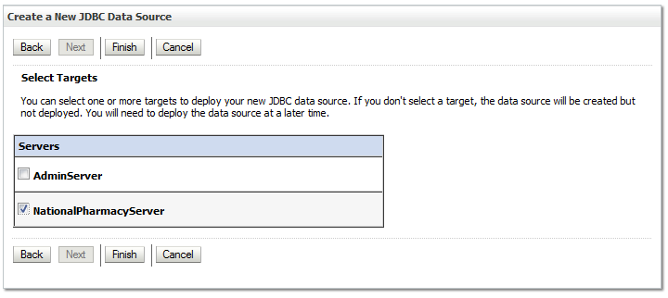

Figure 3‑13. Select Targets

1. Select the Deployment Server as the target. For example, NationalPharmacyServer.
2. Click Finish.
3. WebLogic will now display the panel Summary of JDBC Data Sources in the right column of the console, where the newly created data source is displayed. See Figure 3‑14.

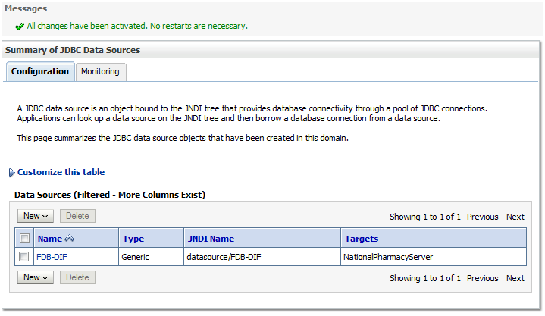

Figure 3‑14. Summary of JDBC Data Sources

1. On these summary page, click on the JDBC source that was just created. Click on the **Connection Pool** tab. The **Maximum Capacity** value is likely set to 15 by default; adjust this value to what is appropriate for the environment. A recommended value of 30 (or more) for NationalEPL, FDB-DIF, and FSS should be sufficient for most cases.
2. After completing the previous steps, remember to repeat all the steps for each database listed in Table 3‑4.

### Server Logs and Log4J configuration

PPS-N uses Log4j to provide debug and error logs. Although the application will function without Log4j installed, using it can be helpful to troubleshoot potential issues. Because PPS-N can operate without Log4j configured, all instructions within this section are only required if debugging deployed code.

If the installation of Log4j is desired, the Java Archive (JAR) file can be found within the PPS-N EAR, or it can be downloaded from the Internet. Please refer to the PPS-N 1.0 Version Description Document for the version required.

#### Warning: Application Server’ Disk Space and Log Files

Due to the sheer volume of log statements issued by the application, the log files can become very large in a very short amount of time. In order to prevent the loss of log information, it is advisable that the application server’s logging feature(s) be configured to “rollover” log files at 10MB and at restart with retention [of older logs] set to 10 or less. Failure to observe this may result in the application behaving in an unexpected, sluggish or error-prone manner as the log files can fill up the disk partition which may in turn inhibit correct functionality of the server and/or the application.

Additionally, WebLogic has “standard out” log files for each server. **This file does not get rotated**. If the log4j.xml configuration file has a “ConsoleAppender” and at least one logger that utilize this appender, these log statements will be directed to the server’s out file, e.g. *domain*/servers/NationalPharmacyServer/logs/NationalPharmacyServer.out. It is absolutely critical to ensure that an appender reference to a ConsoleAppender is not listed in the <root> section of the log4j.xml file, this can cause the “standard out” log file to grow at an exceedingly fast rate.

A log4j.xml configuration that does not use a Console appender will produce no additional output to the “standard out” log file.

##### Domain Logging

Domain-level logging should have a limited number of retained files, and set rotation size as well.

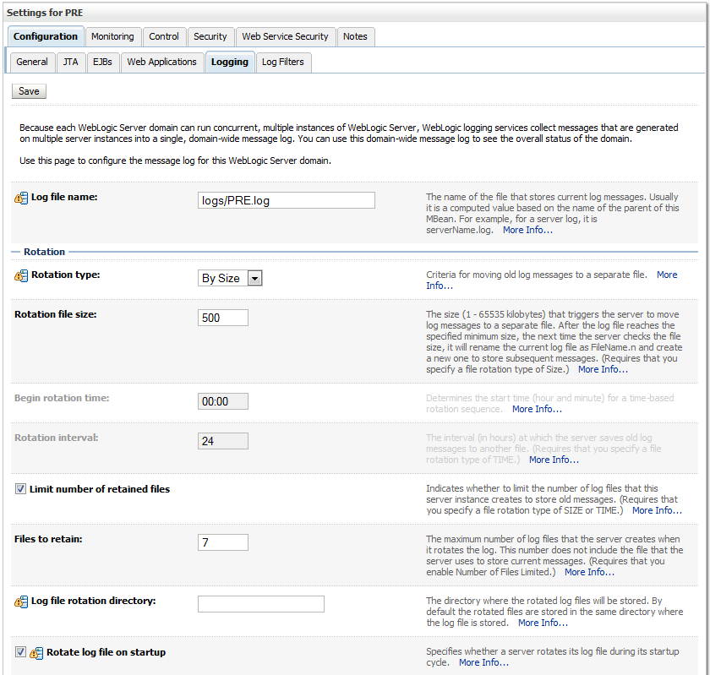

Figure 3‑15. Domain Log File Settings

##### Managed Server Logging

The managed server also allows the additional specification of log file settings. See the figures below as a means of a reference *example* only.

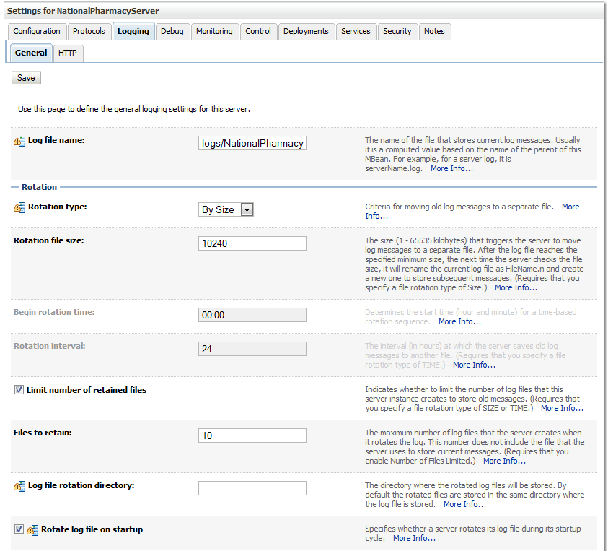

Figure 3‑16. Managed Server Log File Settings

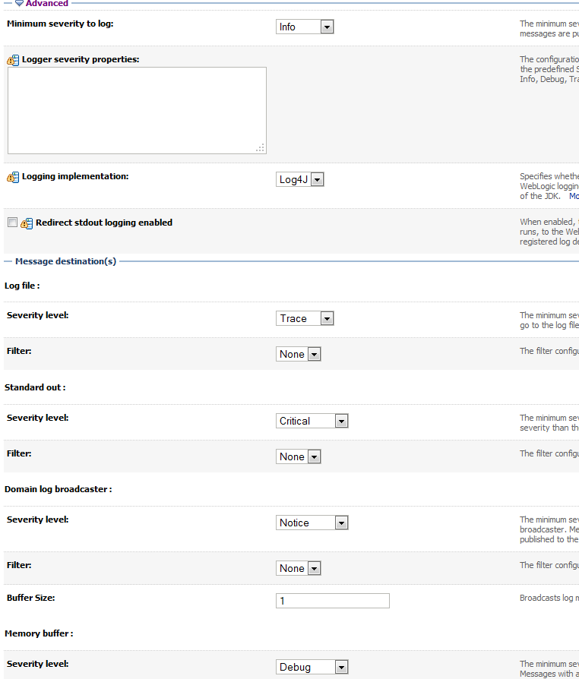

Figure 3‑17. Managed Server Advanced Log File Settings

#### Installation of Log4J

To install Log4j, the Log4j JAR must be placed on the Deployment Server’s class path and the log4j.xml must be edited to include the PPS-N appenders and loggers. Follow the instructions below to place the Log4j library on the Deployment Server’s class path. If Log4j is already installed on the Deployment Server, these steps do not need to be completed.

1. Locate the Deployment Server’s Class Path Directory.
2. Copy the log4j-1.2.14.jar file into a folder within the class path.
3. Configure WebLogic to include the Log4j library in the Deployment Server’s class path. Please refer to the WebLogic documentation provided by Oracle to complete this step.
4. Restart the Deployment Server to load Log4j.

With Log4j installed on the Deployment Server, the log4j.xml file must be modified to include the PPS-N configuration. Note that the appenders place the logs under a log folder. This folder must be created at the same directory level at which the Deployment Server is running. For example, /opt/oracle/domains/PRE/log. Without this folder, Log4j will not be able to create the log files specified in the PPS-N configuration. Alternatively, the file locations could be altered to be placed in a different location. Also note that the ${log4j.logs.dir} Java system property found within the Log4j configuration in Step 2 must either be set or these values must be replaced with the appropriate path to a logs directory. Follow these steps to complete this process:

1. Locate the log4j.xml file used for the Deployment Server. If Log4j has not yet been configured on the Deployment Server, either create a new log4j.xml file that is located in a folder on the Deployment Server class path or use the log4j.configuration Java system property to set the location of the file. Please refer to the WebLogic documentation provided by BEA for configuring the Deployment Server’s class path and the Log4j documentation provided by Apache to complete any of these operations.
2. Add the following configuration to the log4j.xml file:

<appender name="FileAppender" class="org.apache.log4j.RollingFileAppender">

<param name="File" value="${log4j.logs.dir}/server.log"/>

<param name="Append" value="false"/>

<param name="MaxBackupIndex" value="10"/>

<layout class="org.apache.log4j.PatternLayout">

<param name="ConversionPattern" value="%d{dd MMM yyyy hh:mm:ss a} %-5p [%c:%M] %m%n"/>

</layout>

</appender>

<appender name="HibernateAppender" class="org.apache.log4j.RollingFileAppender">

<param name="File" value="${log4j.logs.dir}/hibernate.log"/>

<param name="Append" value="false"/>

<param name="MaxBackupIndex" value="10"/>

<layout class="org.apache.log4j.PatternLayout">

<param name="ConversionPattern" value="%d{dd MMM yyyy hh:mm:ss a} %-5p [%c:%M] %m%n"/>

</layout>

</appender>

<appender name="SpringAppender" class="org.apache.log4j.RollingFileAppender">

<param name="File" value="${log4j.logs.dir}/spring.log"/>

<param name="Append" value="false"/>

<param name="MaxBackupIndex" value="10"/>

<layout class="org.apache.log4j.PatternLayout">

<param name="ConversionPattern" value="%d{dd MMM yyyy hh:mm:ss a} %-5p [%c:%M] %m%n"/>

</layout>

</appender>

<appender name="StrutsAppender" class="org.apache.log4j.RollingFileAppender">

<param name="File" value="${log4j.logs.dir}/struts.log"/>

<param name="Append" value="false"/>

<param name="MaxBackupIndex" value="10"/>

<layout class="org.apache.log4j.PatternLayout">

<param name="ConversionPattern" value="%d{dd MMM yyyy hh:mm:ss a} %-5p [%c:%M] %m%n"/>

</layout>

</appender>

<logger name="org.apache.log4j">

<level value="info" />

</logger>

<logger name="org.hibernate" additivity="false">

<level value="info" />

<appender-ref ref="HibernateAppender"/>

</logger>

<logger name="org.hibernate.type" additivity="false">

<level value="warn" />

<appender-ref ref="HibernateAppender"/>

</logger>

<logger name="org.hibernate.loader" additivity="false">

<level value="warn" />

<appender-ref ref="HibernateAppender"/>

</logger>

<logger name="org.hibernate.impl" additivity="false">

<level value="warn" />

<appender-ref ref="HibernateAppender"/>

</logger>

<logger name="org.springframework" additivity="false">

<level value="error" />

<appender-ref ref="SpringAppender"/>

</logger>

<logger name="org.apache.struts2" additivity="false">

<level value="error" />

<appender-ref ref="StrutsAppender" />

</logger>

<logger name="com.opensymphony.xwork2" additivity="false">

<level value="error" />

<appender-ref ref="StrutsAppender" />

</logger>

<logger name="org.apache.commons.digester" additivity="false">

<level value="error" />

<appender-ref ref="StrutsAppender" />

</logger>

<logger name="freemarker.cache" additivity="false">

<level value="error" />

<appender-ref ref="StrutsAppender" />

</logger>

<logger name="org.apache.tiles" additivity="false">

<level value="error" />

<appender-ref ref="StrutsAppender" />

</logger>

<logger name="net.sf.navigator" additivity="false">

<level value="error" />

<appender-ref ref="StrutsAppender" />

</logger>

<logger name="org.displaytag" additivity="false">

<level value="error" />

<appender-ref ref="StrutsAppender" />

</logger>

<logger name="org.apache.commons">

<level value="warn" />

</logger>

<root>

<priority value="debug" />

<appender-ref ref="FileAppender"/>

</root>

1. If profiling is turned on and should be recorded, add the following configuration to the log4j.xml file:

<appender name="ProfileAppender" class="org.apache.log4j.RollingFileAppender">

<param name="File" value="log/profile.log" />

<param name="Append" value="false" />

<param name="MaxBackupIndex" value="10" />

<layout class="org.apache.log4j.PatternLayout">

<param name="ConversionPattern" value="%d{dd MMM yyyy hh:mm:ss a} %-5p [%c%M] %m%n" />

</layout>

</appender>

<logger name="gov.va.med.pharmacy.peps.common.utility.profile" additivity=”false”>

<level value="info" />

<appender-ref ref="ProfileAppender" />

</logger>

1. Restart the Deployment Server to load the Log4j configuration.

### Site Deployment Configuration

The PPS-N deployment files must be altered to configure the WebLogic deployment descriptor and KAAJEE configuration for each site. The first two sub sections detail configuring these settings. The third sub section details the site configuration properties changed at local and national.

After configuring the application, the result should be EAR deployment files with the exact same file structure as delivered, but with site specific configurations made. The kaajeeConfig.xml, and weblogic.xml files now have the correct values for deployment. Use the original files located on the disk distributed with the PPS-N v1.0 Version Description Document to verify that the file structure is the same.

#### Site Number property

Prior to deploying the ear file a file must be created and placed on the managed server’s class path. This file contains a single line of text that identifies an installation’s site number.

* Create a file named gov.va.med.pharmacy.peps.siteConfig.properties. This file will need to be placed on the managed server’s class path.
* Edit the file, adding [or modifying] the following line:  
  site.number*=<num>*  
  Replace *<num>* with the site VistA Instance number. E.g. 521 (for Birmingham) or 999 for the National instance.

#### WebLogic Deployment Descriptor

Within the PPS-N deployment file, the weblogic.xml deployment descriptor found within the WAR file must be updated to identify the WebLogic administrative user KAAJEE should operate under. To set the user KAAJEE should operate under, follow these steps:

1. Copy the PPS-1.1.02-national.ear file to a chosen target folder. No particular location is required.
2. Unzip the PPS-1.1.02-national.ear file.
3. Unzip the PRE.war file.
4. Open the WEB-INF/weblogic.xml file for editing. This file was contained within the PRE.war file.
5. Change the run-as-principal-name element value to the correct WebLogic administrative user under which KAAJEE should operate. For example:   
   <run-as-principal-name>KAAJEE</run-as-principal-name>
6. Save the changes and close the weblogic.xml file.
7. Repackage (zip) the PRE.war file. The updated file must be located at the root folder of the directly under the PPS-1.1.02-national.ear file. Delete the files unzipped in Step 3.
8. Repackage (zip) the PPS-1.1.02-national.ear file. Delete the files unzipped in Step 2.

#### KAAJEE Station Numbers

Within National PPS-N deployment files, the kaajeeConfig.xml file found within the PRE.war file must be updated to identify the KAAJEE station numbers available for login. To set the KAAJEE station numbers, follow these steps:

1. Copy the PPS-1.1.02-national.ear file to a chosen target folder. No particular location is required.
2. Unzip the ear file.
3. Unzip the PRE.war file.
4. Open the WEB-INF/kaajeeConfig.xml file for editing. This file was contained within the PRE.war file.
5. Change the station-number elements values to the correct KAAJEE station numbers. Multiple station numbers can be configured by adding multiple station-number elements. For example:   
   <station-number>500</station-number>
6. Save the changes and close the kaajeeConfig.xml file.
7. Repackage (zip) the PRE.war file. The updated file must be located at the root folder of the directly under the PPS-1.1.02-national.ear file. Delete the files unzipped in Step 3.
8. Repackage (zip) the PPS-1.1.02-national.ear file. Delete the files unzipped in Step 2.

### Install SQL Load Script Files

The database is reset to a known starting point as part of a user performing the migration process. This is done by the J2EE application running a series of SQL scripts to drop the old data and load the starting data when the user chooses the start migration activity from the PPS-N GUI. These SQL script files must be placed in the config directory of the WebLogic domain. There are 17 files in total, PPSNEPLRefreshData.sql, RefreshEPL_DB.sql and 15 files named PPSEPLRefreshDB1.sql through PPSNEPLRefreshDB15.sql. These are located in the PPSNEPLRefreshDb-1.zip file located on the delivered CD.

### Deployment

The following steps detail the deployment of the PPS-N application. All previous sections must be complete prior to proceeding with the deployment. In addition, the Deployment Server and its WebLogic domain must be restarted to load the changed configuration. Please refer to Section 2.3, Section 2.3.2.3, and Section 2.5 for instructions concerning these configuration items.

After successfully modifying the PPS-N deployment file in Section 2.5.7, repeat the following steps to deploy the application at all National PPS-N instances.

1. Open and log into the WebLogic console, using an administrative user name and password. The WebLogic console is located at: http://<Deployment Machine>:7001/console.
2. Within the Domain Structure panel in the left column of the WebLogic console, click the Deployments node. For reference, see Figure 3‑18.

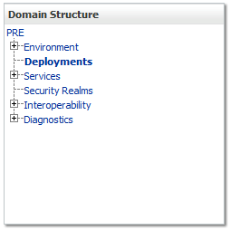

Figure 3‑18. Deployments

1. Click Install found in the Deployments panel in the right column of the WebLogic console. For reference, see Figure 3‑19.

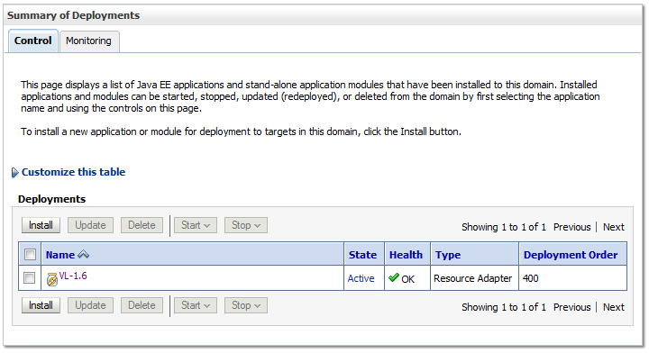

Figure 3‑19. Install Deployment

1. WebLogic will now display the panel Install Application Assistant in the right column of the console, where the location of the PPS-N deployment will be found. For reference, see Figure 3‑20.

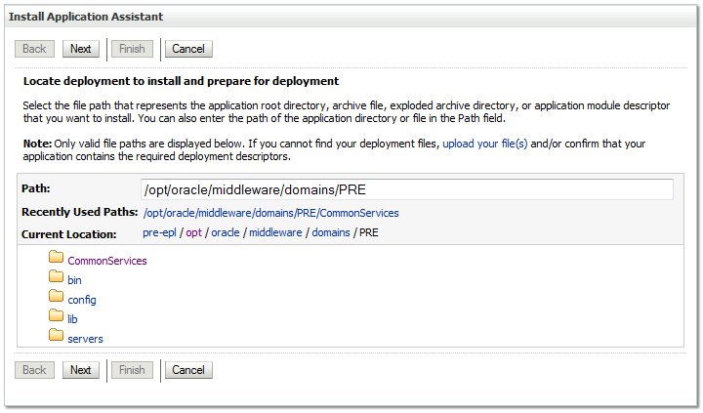

Figure 3‑20. Install Application Assistant

1. Select the site-specific archive for the PPS-N deployment.
   * 1. If the PPS-N deployment has already been transferred to the Deployment Machine, navigate to the deployment file location using the links and file structure displayed within the Location panel within the Install Application Assistant in the right column of the console. For reference, see Figure 3‑21.

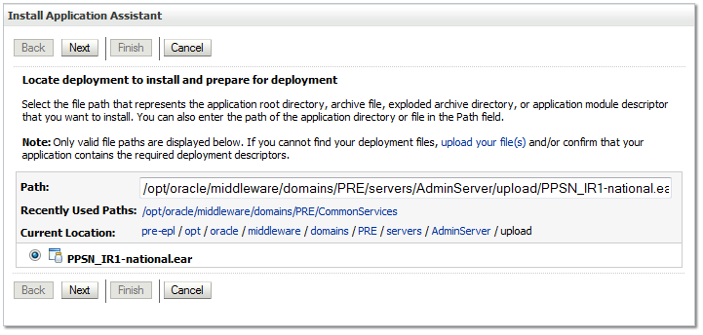

Figure 3‑21. Locate Deployment to Install and Prepare for Deployment

* + 1. If the PPS-N deployment has not been transferred to the Deployment Machine:
       1. Click on the upload your file(s) link in the Install Application Assistant panel in the right column of the console. For reference, see Figure 3‑21.
       2. Click the Deployment Archive Browse to use the Choose file dialogue to select the Deployment Archive to deploy.
       3. Click Next in the Upload a Deployment to the admin server panel in the right column of the WebLogic console to return to the Locate deployment to install and prepare for deployment panel within the Install Application Assistant in the right column of the console. For reference, see Figure 3‑22.

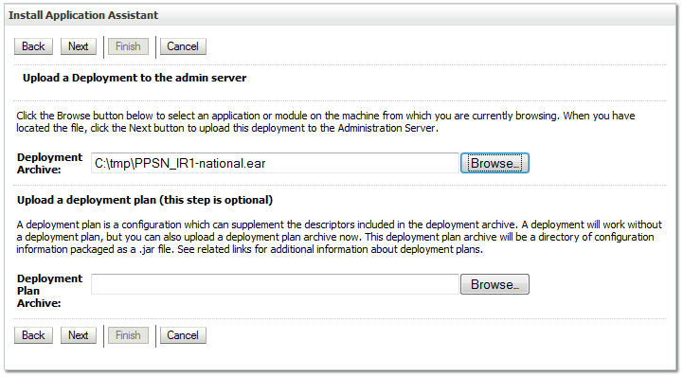

Figure 3‑22. Upload a Deployment to the admin server

1. Once the PPS-N deployment is located and selected, click Next.
2. WebLogic will now display the panel Choose targeting style within the Install Application Assistant in the right column of the console. For reference, see Figure 3‑23.

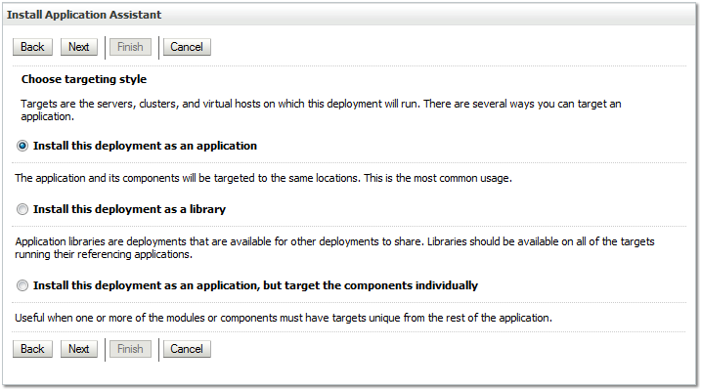

Figure 3‑23. Choose Targeting Style

1. For Choose targeting style, leave the default value selected, Install this deployment as an application.
2. Click Next.
3. WebLogic will now display the panel Select deployment targets within the Install Application Assistant in the right column of the console, where the Deployment Server will be selected as the target in the next step. For reference, see Figure 3‑24.

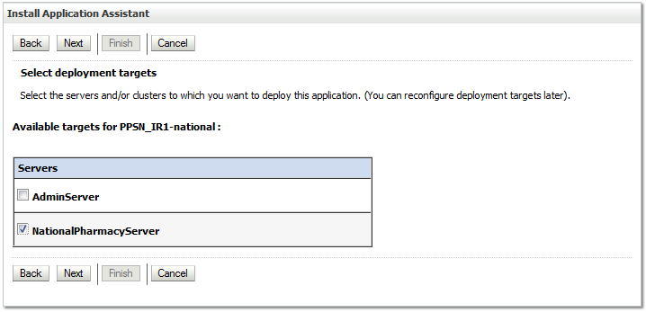

Figure 3‑24. Select Deployment Targets

1. For the Target, select the Deployment Server. For example, NationalPharmacyServer.
2. Click Next.
3. WebLogic will now display the panel Optional Settings within the Install Application Assistant in the right column of the console, where the name of the deployment and the copy behavior are chosen. For reference, see Figure 3‑25.

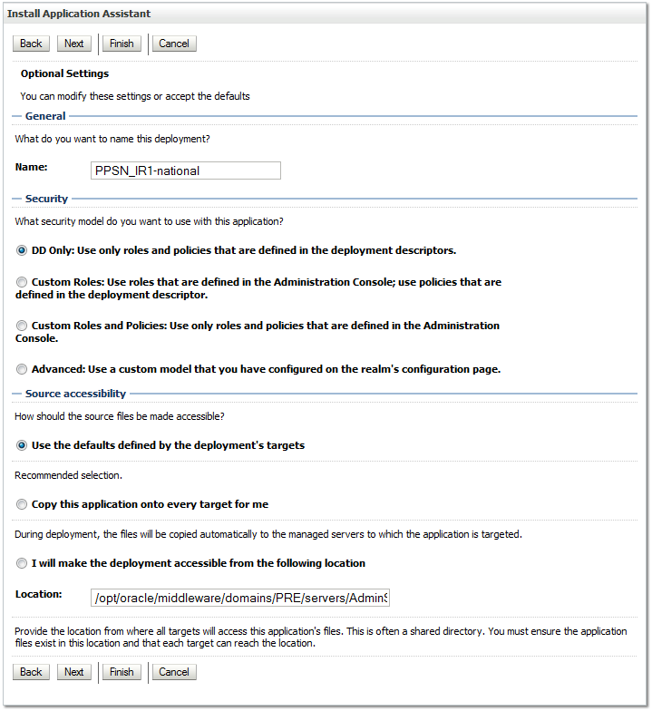

Figure 3‑25. Optional Settings

1. Enter the Name for the deployment. For example, PPSN_IR1-national.
2. Verify that the following default option for Security is selected:

DD Only: Use only roles and policies that are defined in the deployment descriptors.

1. Verify that the following default option for Source accessibility is selected:

Use the defaults defined by the deployment's targets.

1. Click Next.
2. WebLogic will now display the panel Review your choices and click Finish within the Install Application Assistant in the right column of the console, which summarizes the steps completed above. For reference, see Figure 3‑26.

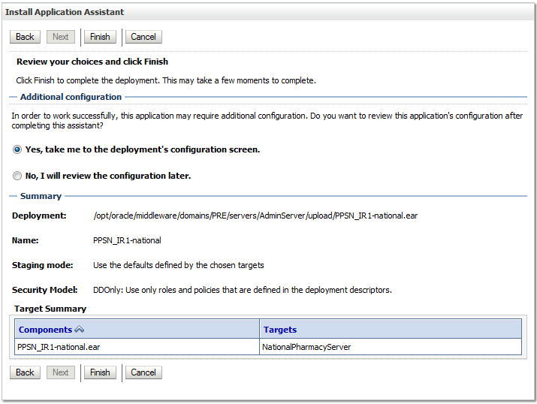

Figure 3‑26. Review Your Choices and Click Finish

1. Verify that the values match those entered in Steps 5 through 18.
2. For Additional configuration, leave the default value Yes, take me to the deployment’s configuration screen set.
3. Click Finish.
4. WebLogic will now display the panel Settings for PPSN_IR1-national in the right column of the console, where the values previously entered are available as well as a setting to change the deployment order. For reference, see Figure 3‑27.

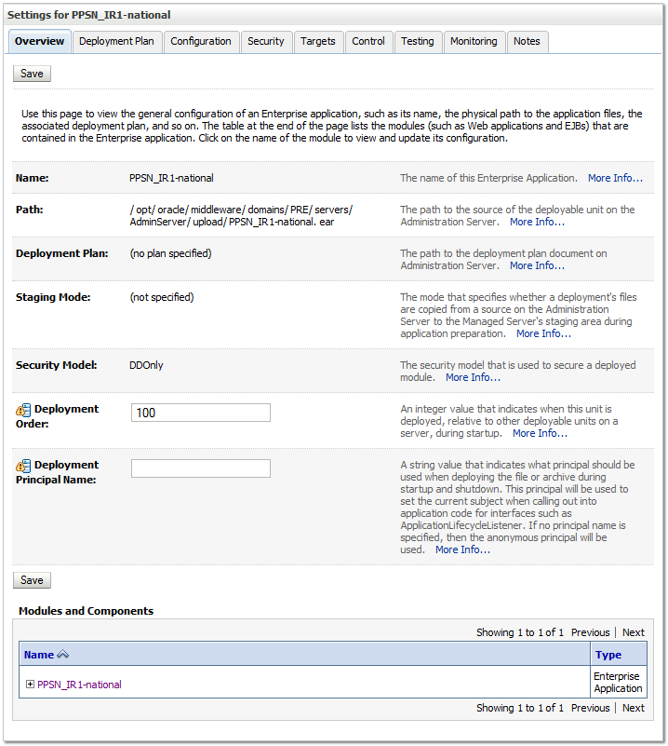

Figure 3‑27. Settings for PRE-1.0-national

1. Leave all the values as defaulted by WebLogic and click Save.
2. Within the Domain Structure panel in the left column of the WebLogic console, click the PRE > Deployments node. For reference, see Figure 3‑28.



Figure 3‑28. Domain Structure

1. WebLogic will now display the panel Summary of Deployments in the right column of the console, where all deployments for the WebLogic domain are listed. For reference, see Figure 3‑29.

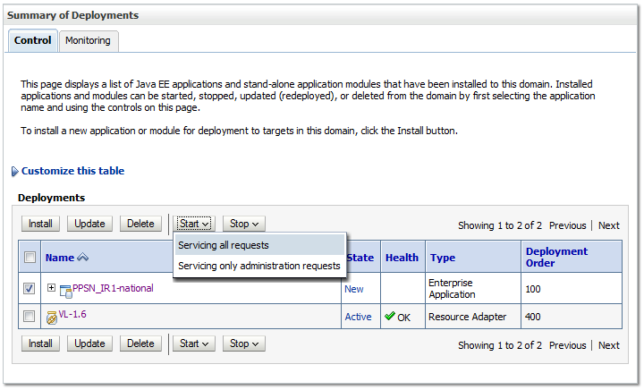

Figure 3‑29. Summary of Deployments

1. Select the previously deployed PPSN-1.1 deployment, and click Start, selecting Servicing all requests from the drop-down list box. Please note this may take an extended amount of time (two or more minutes) depending on server hardware resources.
2. WebLogic now returns to the Summary of Deployments panel in the right column of the console. For reference, see Figure 3‑30.

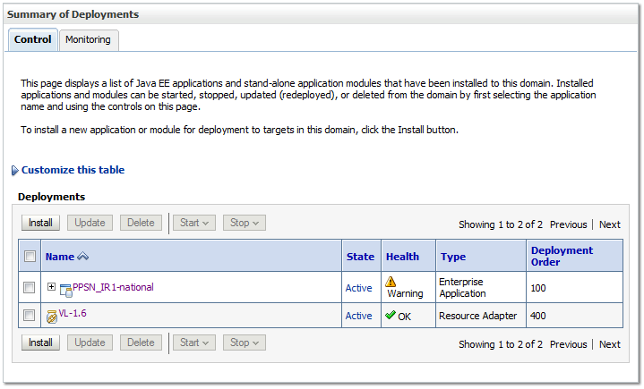

Figure 3‑30. Summary of Deployments - PPS-N Deployment Active

1. Verify that the State of the current PPS-N deployment is Active. For example, PPSN_IR1-national is in the Active state in Figure 3‑30. The browser window may need to be refreshed multiple times before the deployment reaches the Active state.

### Instructions to Undeploy

The following steps detail how to undeploy the PPS-N application:

1. Open and log into the WebLogic console. This is located at: http://<Deployment Machine>:7001/console.
2. Within the Domain Structure panel in the left column of the WebLogic console, click the Deployments node.
3. Within the Change Center panel in the left column of the WebLogic console, click Lock & Edit.
4. In the panel Summary of Deployments in the right column of the console, select the previously deployed PPS-N deployment, click Stop, and then select Force Stop Now from the drop-down list box.
5. WebLogic will now display the panel Force Stop Application Assistant in the right column of the console for confirmation to start servicing requests. Click Yes in the Force Stop Application Assistant panel in the right column of the WebLogic console.
6. WebLogic now returns to the Summary of Deployments panel in the right column of the console. Verify that the State of the PPS-N deployment is Prepared. Select the previously deployed PPS-N deployment, and then click Delete.
7. WebLogic will now display the panel Delete Application Assistant in the right column of the console for confirmation to start servicing requests. Click Yes in the Delete Application Assistant panel in the right column of the WebLogic console.
8. WebLogic now returns to the Summary of Deployments panel in the right column of the console. Verify that the PPS-N deployment is deleted and no longer present.
9. Within the Change Center panel in the left column of the WebLogic console, click Activate Changes.

### Installation of FDB_Images

FDB_Images is the name of the deployment that contains the images utilized by PPSN for the display of images associated with various items within the application. FDB_Images is an open-directory type deployment that needs to be added to the server so that PPSN works correctly. As a separate and open-directory deployment, this allows the modification of the image contents within the deployment, such as adding monthly image updates from First Data Bank.

#### Deployment of FDB_Images.zip

Deploying the FDB_Images directory consists of the following:

Unzip the FDB_Images.zip archive to an appropriate location on the server. This location must be readable by the user account used by Web Logic. This is the folder where the FDB images that are displayed in the PPSN are retrieved.  Any application (such as DATUP) and any administrator that updates the images should put the FDB images in this folder.

1. Open a web browser to the WebLogic console
2. Click on the Deployments link
3. Click Install button
4. Navigate to the directory that contains FDB_Images. E.g. /opt. It should have an entry listed as “FDB_Images (open directory).”
5. Click on “FDB_Images (open directory)” radio button to its left.
6. Click the Next button.
7. Click “Install this deployment as an application”
8. Click Next
9. Select the server(s) this should be deployed to, e.g. “NationalPharmacyServer”
10. Click Next.
11. Optional settings:
    * Name: “FDB_Images” - required. This is the “*deployment name*”
    * Security, click “DD Only: Use only roles…”
    * Source accessibility, click “I will make the deployment accessible from the following location”. The location listed should suffice. This tells WebLogic to use this directory directly and to ***not*** copy it, so adequate permissions will be needed on the directory so that it and its contents are readable to the web.
12. Click Next.
13. Click “Yes, take me to the deployment’s configuration screen”
14. Click Finish.
15. On the configuration screen, change Deployment Order to “200”
16. Click Save.

If a different *deployment name* is used, you will need to account for this by specifying the name in the PPS-N configuration file’s FDBImageLocation element. See Section 7, PPS-N Configuration File.

# Checklist

## External Connectivity

PPS-N connects to some resources that may be restrained by firewall or other security configurations.

### STS

Outbound connections are made to the STS service, as such security setting must be altered to allow outbound connections from the PPS-N environment to the respective URL.

|  |  |
| --- | --- |
| Environment | URL |
| Staging | http://islvsswls2.fo-slc.med.va.gov:9205/sts.webservice/ctService |
| Pre-production / production | http://vahdrppwls14.aac.va.gov:7205/sts.webservice/ctService |

## Database Connectivity

Ensure connectivity to the following datasources:

* PPSNEPL
* FDB-DIF
* FSS

## Database Population

The database is populated by means of section 3.3.2.2 or 3.3.2.3

## Database Permissions

Permissions have been set on the PPSNEPL account according to section 3.3.3.

## Dependent WebLogic Deployments or Configurations

* VistAlink and KAAJEE are configured and working
* FDB_Images folder must be available as a deployment, see section 3.5.10

## PPS-N Configuration

Within the PPS-NConfig.xml file, note the following:

* The value of the NationalPort element must match the port number the WebLogic managed server is using
* The value of NDFProxyUserIEN must be an existing and valid proxy user on the NDF system

## Site Number

The file, gov.va.med.pharmacy.peps.siteConfig.properties, must be created and an appropriate value set, see section 3.5.7.1.

*(This page included for two-sided copying.)*

# Functionality Test

The following instructions define a method of verifying the installation performed in Section 3. These steps are not required to complete the PPS-N installation; they provide a way to verify that the installation is complete and operational.

## Assumptions

Prior to completing any of the deployment verification instructions in the remaining section of this document, the following assumption must be met: The PPS-N Web interface is accessed using Internet Explorer, Version 9.

## Deployment Verification

The following instructions detail how to verify that the PPS-N system was deployed successfully. The instructions do not verify all functionality of the application; they are only a simple way to show that the deployment was successful.

For each deployment environment, follow these steps:

1. Store the SampleNDC.csv file in a directory on the computer that will run the Web browser.
2. Open a Web browser.
3. Navigate to http://<Deployment Machine>:<Deployment Server Port>/PRE/
4. Login using the following username: PNM1N1
5. Verify that the PPS-N home page appears.
6. Select the Migrate tab. Verify the Migration Start page appears.
7. Start a migration as follows:
   * Select the SampleNDC.csv file stored in step 1.
   * Select Start Migration button.
8. Wait for a partial migration (Drug Units and Dispense Units only) to complete. Press Stop button if migration time exceeds two minutes.
9. On Migration Report page, review Drug Unit and VA Dispense Unit detailed reports by selecting the appropriate links.

If the Web pages do not appear or the flow is not fully operational, verify that all the steps listed in Section 3 were completed correctly.

*(This page included for two-sided copying.)*

# Backout Procedures

The current PPS-N Application is hosted on the NDF Management Server. When PPS-N goes online; the users will simply stop using the MUMPS user interface in the NDF Management Server and begin using the web interface to manage drug items. As new drugs items are added into PPS-N and existing items are updated, the PPS-N java application will be automatically updating the NDF Management System in the background.

If, at any time, the users decide to stop using the PPS-N web application and go back to using the NDF Management user interface, it is simply a matter of stopping using the web service and starting using the NDF interface. Since the PPS-N web interface keeps the NDF Management System updated in real-time then no rollback procedure is to be performed.

There is already a procedure in place that is used to back up the NDF Management Server and that process will continue as is with no changes. The periodic backup of the PPS-N EPL database is described in the Productions Operational Manual.

*(This page included for two-sided copying.)*

# PPS-N Configuration File

This configuration file (PPS-NConfig.xml) needs to be in the directory structure of the application server. It must be in the /config directory of the deployed domain (i.e. ../domains/PRE/config/).

<?xml version = *"1.0"* encoding = *"UTF-8"*?>

<PPS-NConfigFile>

<NationalPort>8021</NationalPort>

<TransactionTimeout>60</TransactionTimeout>

<NDFDivision>521</NDFDivision>

<NDFProxyUserIEN>355</NDFProxyUserIEN>

<ConnectionSpecName>DUZ</ConnectionSpecName>

<RPCTimeout>60000</RPCTimeout>

<FDBImageLocation>/FDB_Images/</FDBImageLocation>

</PPS-NConfigFile>

Please note that the FDBImageLocation element is optional, as a default value of “/FDB_Images/” is used if it is not specified.

*(This page included for two-sided copying.)*

# Troubleshooting

## In an SSL-enabled environment, the application’s responsiveness is extremely slow

When using an Apache web server for SSL, ensure the KeepAlive directive is set to ON. By default, the installation sets this value to OFF.